Inheritance
Inheritance is a process of acquiring the properties and behavior of one class inside another class.
Inheritance is process of using the content (variables and methods) of one class inside another class.
Inheritance allows developing new data type using existing data type.
Inheritance allows grouping all the classes which share common properties and behavior into one type.

Advantage of inheritance
- Reusability
- Extensibility
- Modularity

Reusability: This allows to use the variables and methods of one class inside another class.
Extensibility: This allows to extend the functionality or features of existing class without modifying it
Modularity: allows dividing content into number of classes.

Inheritance generate “is-a” relationship between classes.
Inheritance in Python is a fundamental concept in object-oriented programming (OOP) that allows a new class (the child class) to derive properties and behaviors from an existing class (the parent class). This promotes code reusability and helps structure code in a hierarchical manner.

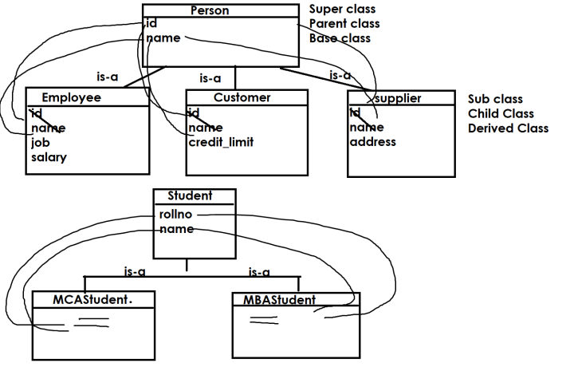
Based on the reusability and organization classes python support different types of inheritance
- Single Level Inheritance
- Multi Level Inheritance
- Multiple Inheritance
- Hierarchical Inheritance
- Hybrid Inheritance

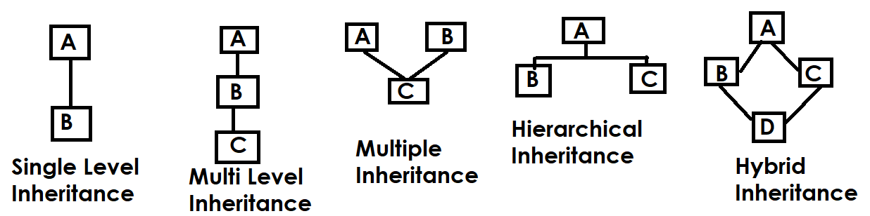

Syntax:
class derived-class-name(base-class-name,base-class-name,..):
variables
methods

Existing class is called base class (OR) parent class (OR) super class
The class which is created using existing class is called derived class (OR) child class (OR) sub class.

Single Level Inheritance
In single level inheritance there is one base class and derived class.

class A: # Parent Class
def m1(self):
print("m1 method of A class")
def m2(self):
print("m2 method of A class")

class B(A): # Child class
def m3(self):
print("m3 method of B class")

objb=B()
objb.m1()
objb.m2()
objb.m3()

Output
m1 method of A class
m2 method of A class
m3 method of B class

Methods of parent class or super class or base class are automatically inherited within child class or sub class or derived class.

class Parent:
def walk(self):
print("Parent Walk")

class Child(Parent):
def run(self):
print("Child Run")

c1=Child()
c1.walk()
c1.run()

Output
Parent Walk
Child Run

Example:
class A: # Parent class
def __init__(self):
self.x=100
self.y=200

class B(A): # Child class
def __init__(self):
A.__init__(self)
self.p=300
self.q=400

objb=B()
print(objb.p,objb.q)
print(objb.x,objb.y)

Output
300 400
100 200

The properties of parent class are not inherited automatically inside child class in order to inherit, child class constructor must call the constructor of parent class.

# Single Level Inheritance
class Person: # Super Class/Base class/Parent Class
def __init__(self):
self.__name=None
def setName(self,n):
self.__name=n
def getName(self):
return self.__name

class Student(Person): # Sub Class/Derived Class/Child Class
def __init__(self):
Person.__init__(self)
self.__course=None
def setCourse(self,c):
self.__course=c
def getCourse(self):
return self.__course

stud1=Student()
stud1.setName("Naresh")
stud1.setCourse("PYTHON")
print(f'{stud1.getName()},{stud1.getCourse()}')

Output
Naresh,PYTHON

Multi Level Inheritance
If a class is derived from another derived class, it is called multi level inheritance.

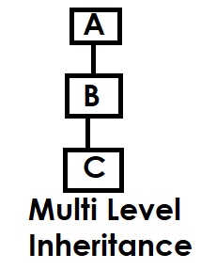

Example:
class A:
def m1(self):
print("m1 of A class")

class B(A):
def m2(self):
print("m2 of B class")

class C(B):
def m3(self):
print("m3 of C class")

objc=C()
objc.m1()
objc.m2()
objc.m3()

Output
m1 of A class
m2 of B class
m3 of C class

Example:
class Person: # Base class/Parent class
def __init__(self):
self.__name=None
def setName(self,n):
self.__name=n
def getName(self):
return self.__name

class Employee(Person): # Child class of Person/Parent class of Salaried Employee
def __init__(self):
Person.__init__(self)
self.__job=None
def setJob(self,j):
self.__job=j
def getJob(self):
return self.__job

class SalariedEmployee(Employee): # Child class
def __init__(self):
Employee.__init__(self)
self.__salary=None
def setSalary(self,s):
self.__salary=s
def getSalary(self):
return self.__salary

emp1=SalariedEmployee()
emp1.setName("Ramesh")
emp1.setJob("HR")
emp1.setSalary(45000)
print(f'{emp1.getName()},{emp1.getJob()},{emp1.getSalary()}')

Output
Ramesh,HR,45000

Multiple Inheritance
If a class is derived from more than one base class is called multiple inheritance.

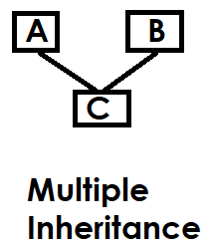

class A:
def m1(self):
print("m1 of A class")

class B:
def m2(self):
print("m2 of B class")

class C(A,B):
def m3(self):
print("m3 of C class")

objc=C()
objc.m1()
objc.m2()
objc.m3()

Output
m1 of A class
m2 of B class
m3 of C class

# Multiple Inheritance
class Person:
def __init__(self):
self.__name=None
def setName(self,n):
self.__name=n
def getName(self):
return self.__name

class Account:
def __init__(self):
self.__accno=None
def setAccno(self,ac):
self.__accno=ac
def getAccno(self):
return self.__accno

class SavingAccount(Person,Account):
def __init__(self):
Person.__init__(self)
Account.__init__(self)
self.__balance=None
def setBalance(self,b):
self.__balance=b
def getBalance(self):
return self.__balance

acc1=SavingAccount()
acc1.setAccno(1)
acc1.setName("Ramesh")
acc1.setBalance(45000)
print(f'''AccountNo {acc1.getAccno()}
CustomerName {acc1.getName()}
CustomerBalance {acc1.getBalance()}''')

Output
AccountNo 1
CustomerName Ramesh
CustomerBalance 45000

Inheritance allows to develop similar data types
In inheritance super class is called generalized class (which is developed based on commonality)
The class which is inherited from generalized class is called specialized class.

Hierarchical inheritance
If more than one class derived from same base class, it is called hierarchical inheritance.

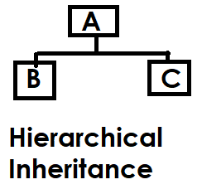

Example:
# Hierarchical Inheritance

class Person:
def __init__(self):
self.__name=None
def setName(self,n):
self.__name=n
def getName(self):
return self.__name

class Employee(Person):
def __init__(self):
Person.__init__(self)
self.__job=None
def setJob(self,j):
self.__job=j
def getJob(self):
return self.__job

class Customer(Person):
def __init__(self):
Person.__init__(self)
self.__creditlimit=None
def setCreditLimit(self,c):
self.__creditlimit=c
def getCreditLimit(self):
return self.__creditlimit

emp1=Employee()
cust1=Customer()
emp1.setName("ramesh")
emp1.setJob("HR")
cust1.setName("kishore")
cust1.setCreditLimit(45000)
print(f'''EmployeeDetails
EmploeeName :{emp1.getName()}
EmployeeJob :{emp1.getJob()}''')
print(f'''CustomerDetails
CustomerName :{cust1.getName()}
CustomerCreditlimit :{cust1.getCreditLimit()}''')

Output
EmployeeDetails
EmploeeName :ramesh
EmployeeJob :HR
CustomerDetails
CustomerName :kishore
CustomerCreditlimit :45000

Hybrid Inheritance
Organizing of classes using more than one type of inheritance is called hybrid inheritance

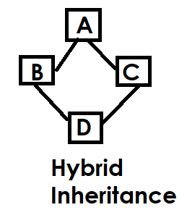

# Hybrid Inheritance

class A:
def m1(self):
print("m1 of A")

class B(A):
def m2(self):
print("m2 of B")
class C(A):
def m3(self):
print("m3 of C")
class D(B,C):
def m4(self):
print("m4 of D")

objd=D()
objd.m1()
objd.m2()
objd.m3()
objd.m4()

Output
m1 of A
m2 of B
m3 of C
m4 of D

Polymorphism

“Poly” means many and “morphism” is forms
Defining one thing in many forms is called polymorphism.
Polymorphism allows reusability and extensibility.
Python supports 2 types of polymorphism
- Method Overriding
- Operator Overloading

Method Overriding
Defining method in subclass with same signature (name, parameters) of method exists in super class is called method overriding.
(OR) defining method in sub class with same name and parameters of method exists in super class is called method overriding.
Method is override to modify or extend functionality of base class method within derived class.

